**Exercise 1: Mocking and Stubbing**

**Scenario:**

**You need to test a service that depends on an external API. Use Mockito to mock the**

**external API and stub its methods.**

**Steps:**

**1. Create a mock object for the external API.**

**2. Stub the methods to return predefined values.**

**3. Write a test case that uses the mock object.**

**CODE:**

MyServiceTest.java

import static org.mockito.Mockito.*;

import org.junit.jupiter.api.Test;

import org.mockito.Mockito;

public class MyServiceTest {

@Test

public void testExternalApi() {

ExternalApi mockApi = Mockito.mock(ExternalApi.class);

when(mockApi.getData()).thenReturn("Mock Data");

MyService service = new MyService(mockApi);

String result = service.fetchData();

assertEquals("Mock Data", result);

}

}

MyService.java

public class MyService {  
 private ExternalApi api;  
  
 public MyService(ExternalApi api) {  
 this.api = api;  
 }  
  
 public String fetchData() {  
 return api.getData();  
 }  
}

ExternalApi.java

public interface ExternalApi {  
 String getData();  
}

**OUTPUT:**

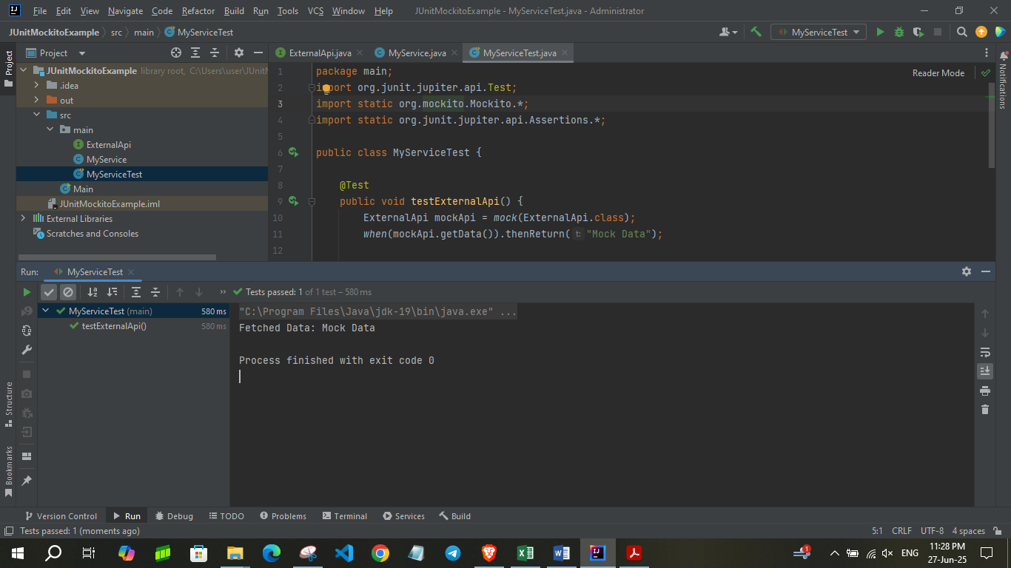

**Exercise 2: Verifying Interactions**

**Scenario:**

**You need to ensure that a method is called with specific arguments.**

**Steps:**

**1. Create a mock object.**

**2. Call the method with specific arguments.**

**3. Verify the interaction.**

**CODE:**

ExternalApi.java

public interface ExternalApi {  
 String getData();  
}

MyService.java

import static org.mockito.Mockito.*;

import org.junit.jupiter.api.Test;

import org.mockito.Mockito;

public class MyServiceTest {

@Test

public void testVerifyInteraction() {

ExternalApi mockApi = Mockito.mock(ExternalApi.class);

MyService service = new MyService(mockApi);

service.fetchData();

verify(mockApi).getData();

}

}

**OUTPUT:**

